**Department of Computer Science and Engineering**

**National Institute of Technology, Hamirpur**

**Name: Aryan Puri**

**Roll Number: 22BEC032**

**Digital Image Processing Lab (CS-325)**

**Solution Laboratory Assignment -1**

**Topic: Spatial Image Enhancement functions and interpretation of results**

**Question 1: Design a program to read a bmp file and do the inversion and sub-sampling. Write the conclusion based on the observation of the output image.**

**Solution:**

1. **Inversion of Image**

**Python Program:**

import cv2

import numpy as np

import matplotlib.pyplot as plt

image=cv2.imread('./Assignment 1/MR.pgm',0)

height=image.shape[0]

width=image.shape[1]

image2=np.ones((height,width),dtype=np.uint8)

hi=[0]*256

ho=[0]*256

for i in range(height):

    for j in range(width):

        image2[i][j]=255-image[i][j]

        hi[image[i][j]]+=1

        ho[image2[i][j]]+=1

cv2.imshow('Orignal Image',image)

cv2.imshow('Inversion Image',image2)

for i in range(256):

    hi[i]=hi[i]/(height*width)

    ho[i]=ho[i]/(height*width)

plt.plot(hi)

plt.title('Input Image Histogram')

plt.show()

plt.plot(ho)

plt.title('Output Image Histogram')

plt.show()

cv2.waitKey(0)

cv2.destroyAllWindows()

**Input Image: Output Image:**

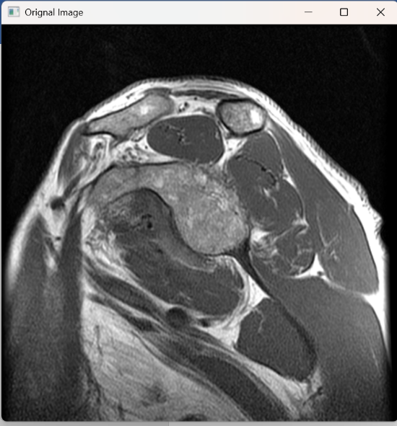 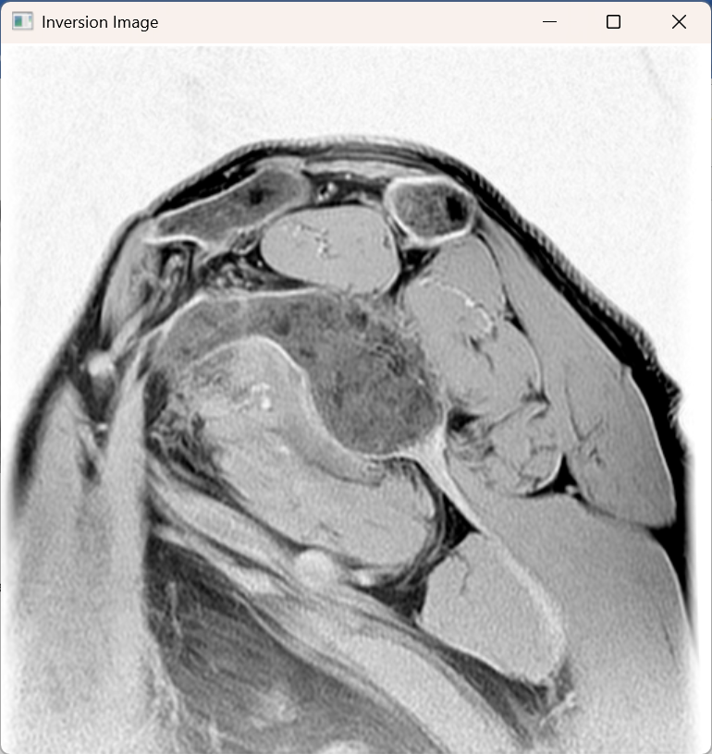

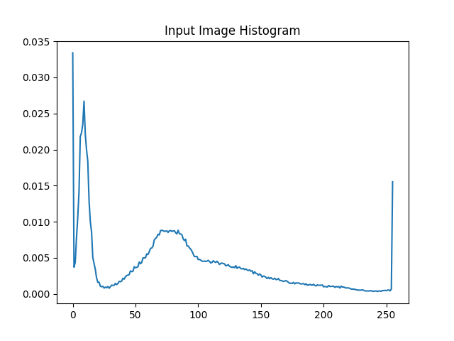 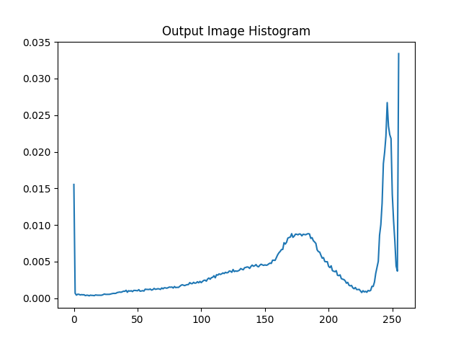

**Conclusion:**The Output Image is negative of the input image also the input and output histograms are inverse of each other.

1. **Sub Sampling**

**Python Program:**

import numpy as np

import cv2

image=cv2.imread('./Assignment 1/MR.pgm',0)

image=cv2.resize(image,(512,512))

height=image.shape[0]

width=image.shape[1]

image2=np.ones((int(height/2),int(width/2)),dtype=np.uint8)

for i in range(height):

    for j in range(width):

        if(i%2==0):

            if(j%2==0):

                image2[int(i/2)][int(j/2)]=image[i][j]

cv2.imshow('Orignal Image',image)

cv2.imshow('Sub Sampled Image',image2)

cv2.waitKey(0)

cv2.destroyAllWindows()

**Input Image: Output Image:**

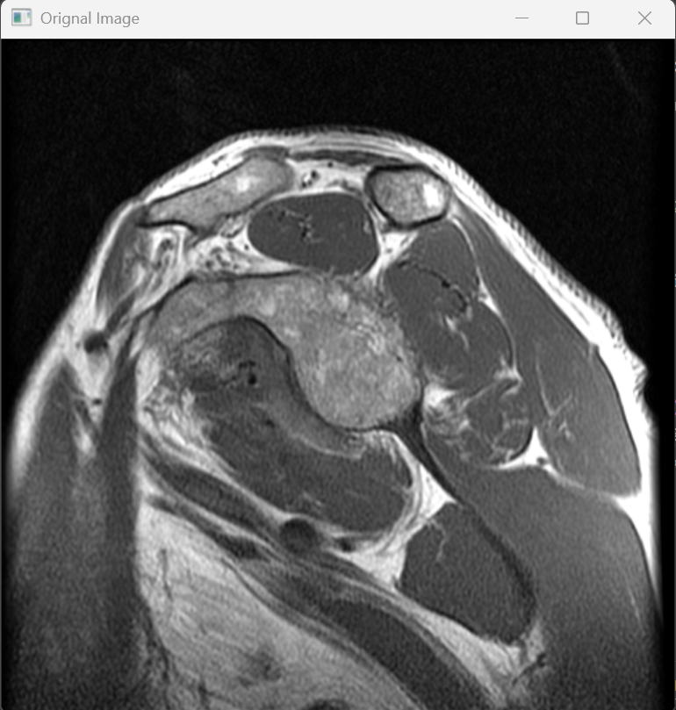 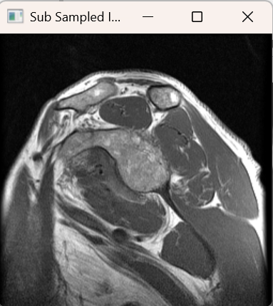

**Conclusion:**The Output Image is sub sampled of the input image and having the dimensions half of the original image.

**Question 2: Design a program to read a bmp and pgm file and do the following enhancement operations in spatial domain**

**Solution:**

**A) Contrast stretching**

**Python program:**

import numpy as np

import math

import cv2

import matplotlib.pyplot as plt

image=cv2.imread('./Assignment 1/boats.bmp',0)

height=image.shape[0]

width=image.shape[1]

hi=[0]*256

ho=[0]*256

image2=np.ones((height,width),dtype=np.uint8)

for i in range(height):

    for j in range(width):

        if(image[i][j]<20):

            image2[i][j]=0

        elif(image[i][j]<200):

            image2[i][j]=round(255*((image[i][j]-20)/180))

        else:

            image2[i][j]=255

        hi[image[i][j]]+=1

        ho[image2[i][j]]+=1

graph=[0]*256

for i in range(256):

    if(i<20):

        graph[i]=0

    elif(i<200):

        graph[i]=round(255*((i-20)/180))

    else:

        graph[i]=255

cv2.imshow('Orignal Image',image)

cv2.imshow('Contrast Enhancement Image',image2)

for i in range(256):

    hi[i]=hi[i]/(height*width)

    ho[i]=ho[i]/(height*width)

plt.plot(graph)

plt.title('\nS={0 if R<20;\n (R-20)/180 if 20<R<200;\n 255 if R>200}\n')

plt.xlabel('R')

plt.ylabel('S')

plt.show()

plt.plot(hi)

plt.title('Input Image Histogram')

plt.show()

plt.plot(ho)

plt.title('Output Image Histogram')

plt.show()

cv2.waitKey(0)

cv2.destroyAllWindows()

**Contrast Enhancement Function:**

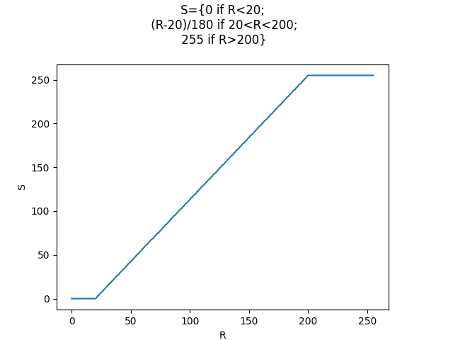

**Input Image: Output Image:**

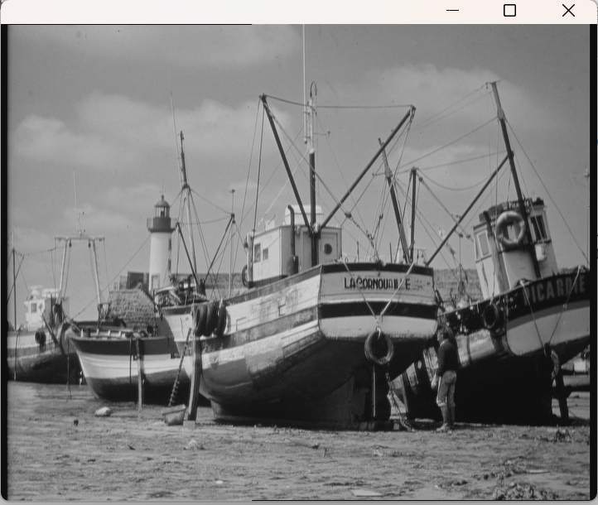 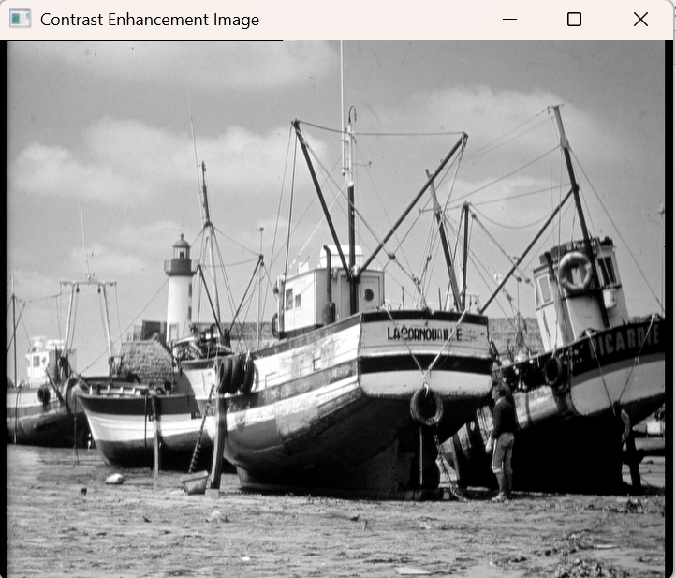

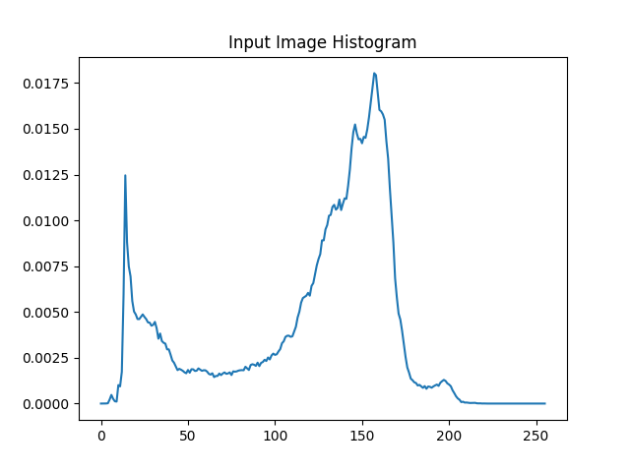 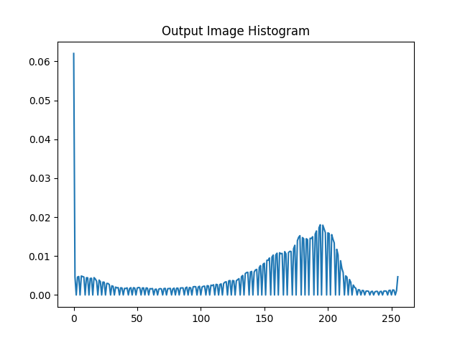

**B) Log Transformation**

**Python Program:**

import cv2

import numpy as np

import math

import matplotlib.pyplot as plt

image=cv2.imread('./Assignment 1/ultrasound.pgm',0)

height=image.shape[0]

width=image.shape[1]

hi=[0]*256

ho=[0]*256

image2=np.ones((height,width),dtype=np.uint8)

for i in range(height):

    for j in range(width):

        if(image[i][j]>0):

            image2[i][j]=int(32 * math.log(image[i][j],2))

        else:

            image2[i][j]=0

        hi[image[i][j]]+=1

        ho[image2[i][j]]+=1

graph=[0]*256

for i in range(256):

    graph[i]=int(32 * math.log(i+1,2))

cv2.imshow('Orignal Image',image)

cv2.imshow('Log Transformation Image',image2)

for i in range(256):

    hi[i]=hi[i]/(height*width)

    ho[i]=ho[i]/(height*width)

plt.plot(graph)

plt.title('\nS=clog(1+R)\n')

plt.xlabel('R')

plt.ylabel('S')

plt.show()

plt.plot(hi)

plt.title('Input Image Histogram')

plt.show()

plt.plot(ho)

plt.title('Output Image Histogram')

plt.show()

cv2.waitKey(0)

cv2.destroyAllWindows()

**Log Transformation Function**

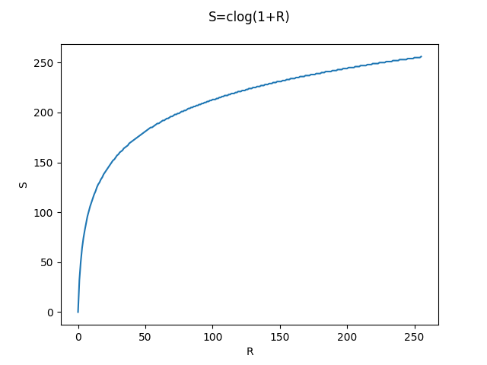

**Input Image: Output Image:** 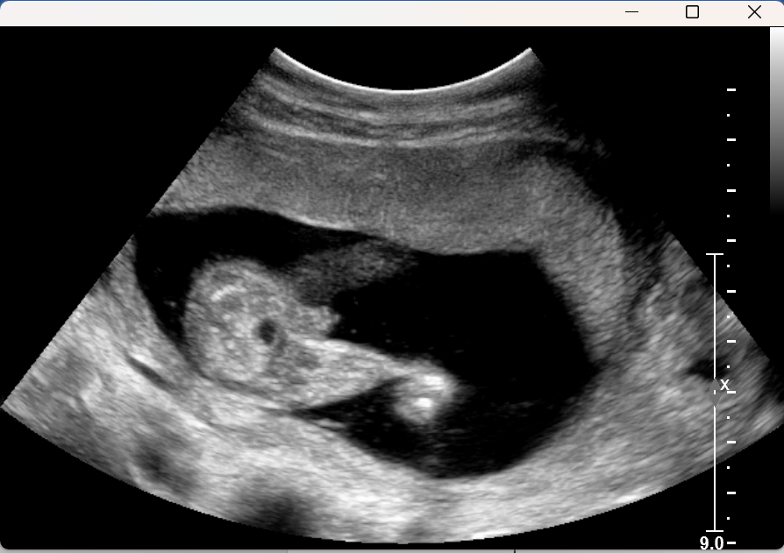 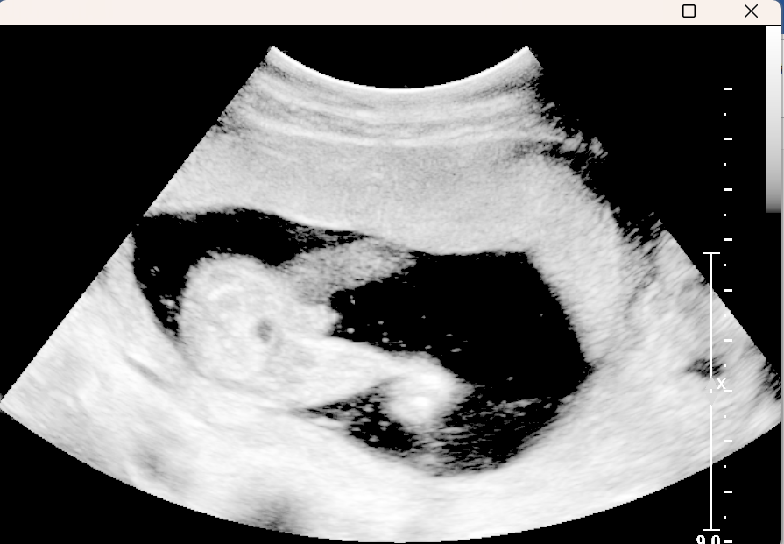

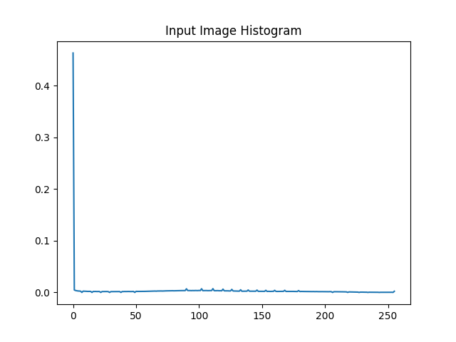 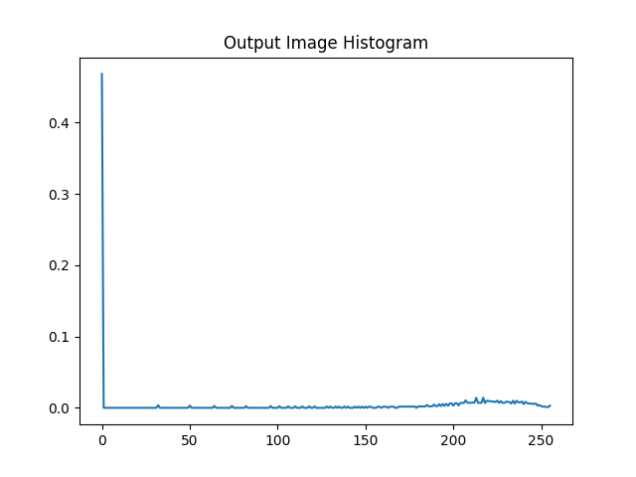

1. **Power Law Transformation**

**Python Program:**

import numpy as np

import cv2

import math

import matplotlib.pyplot as plt

image=cv2.imread('./Assignment 1/boats.bmp',0)

height=image.shape[0]

width=image.shape[1]

image3=np.ones((height,width),dtype=np.uint8)

image4=np.ones((height,width),dtype=np.uint8)

image5=np.ones((height,width),dtype=np.uint8)

ho3=[0]*256

ho4=[0]*256

ho5=[0]*256

hi=[0]*256

for i in range(height):

    for j in range(width):

        hi[image[i][j]]+=1

        image3[i][j]=round(48*math.pow(image[i][j],0.3))

        image4[i][j]=round(27*math.pow(image[i][j],0.4))

        image5[i][j]=round(14*math.pow(image[i][j],0.5))

        ho3[image3[i][j]]+=1

        ho4[image4[i][j]]+=1

        ho5[image5[i][j]]+=1

graph3=[0]*256

graph4=[0]*256

graph5=[0]*256

for i in range(256):

    graph3[i]=round(48*math.pow(i,0.3))

    graph4[i]=round(27*math.pow(i,0.4))

    graph5[i]=round(14*math.pow(i,0.5))

cv2.imshow('Orignal Image',image)

cv2.imshow('Power Law Transformation (b=0.3) Image',image3)

cv2.imshow('Power Law Transformation (b=0.4) Image',image4)

cv2.imshow('Power Law Transformation (b=0.5) Image',image5)

for i in range(256):

    hi[i]=hi[i]/(height*width)

    ho3[i]=ho3[i]/(height*width)

    ho4[i]=ho4[i]/(height*width)

    ho5[i]=ho5[i]/(height*width)

plt.plot(graph3,label='b=0.3')

plt.plot(graph4,label='b=0.4')

plt.plot(graph5,label='b=0.5')

plt.legend()

plt.title('\nS=c(R^b)\n')

plt.xlabel('R')

plt.ylabel('S')

plt.show()

plt.plot(hi)

plt.title('Histogram of Input')

plt.show()

plt.plot(ho3)

plt.title('Histogram of Output (b=0.3)')

plt.show()

plt.plot(ho4)

plt.title('Histogram of Output (b=0.4)')

plt.show()

plt.plot(ho5)

plt.title('Histogram of Output (b=0.5)')

plt.show()

cv2.waitKey(0)

cv2.destroyAllWindows()

**Power law Transformation Function**

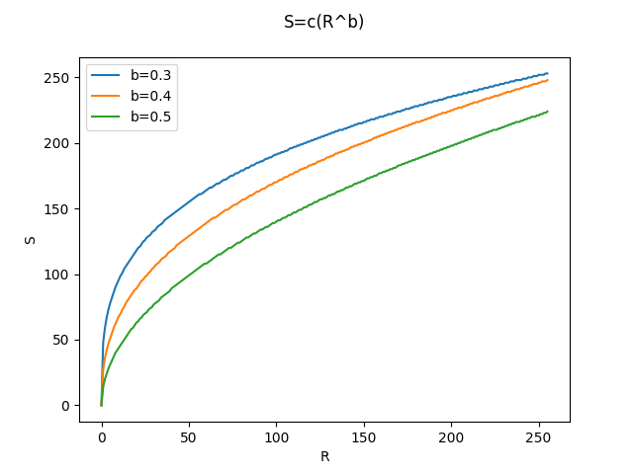

**Input Image: Output Image (b=0.3):**

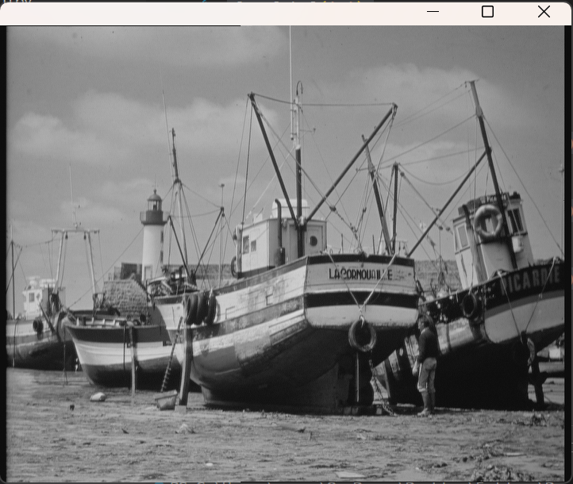 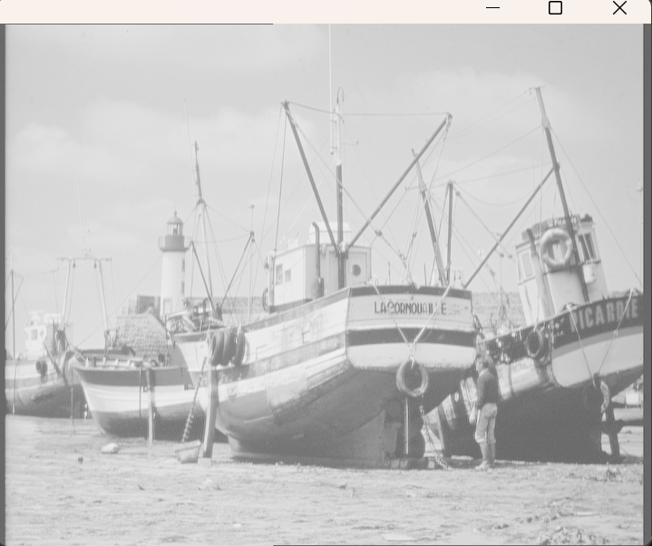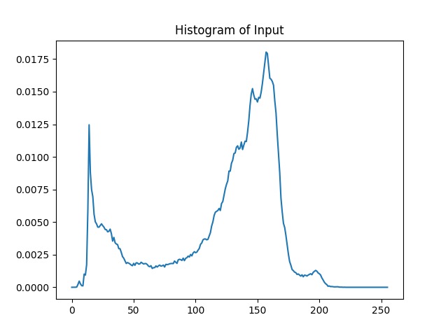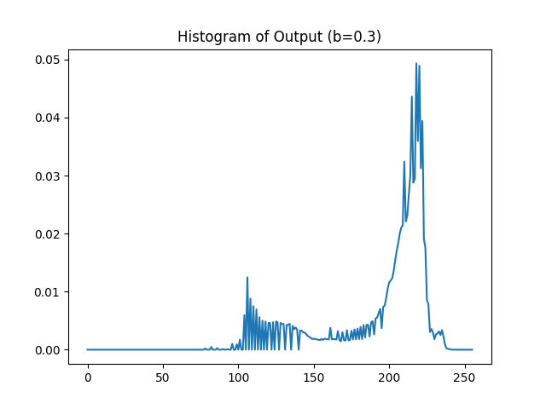

**Output Image (b=0.4) Output Image (b=0.5)**

